A000-Eur-Bulgaria-Stara Zagora-Bust with Punctures-Ceramic-6th Millennium BCE-Neolithic 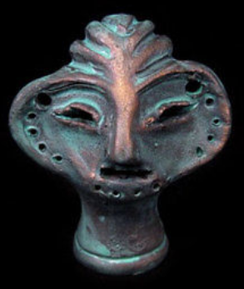

**Accession Number: A000**

**Formal Label: Bulgaria** Neolithic Ceramic Idol 6th Millennium BCE

**Display Description:** These Stara Zagora heads are unique and represent the differentiation of communities as they expressed their singular artistic and mythological ideas in ceramics (Gaul 1948).

**LC Classification:**  GN776.B9

**Date or Time Horizon:** 6th Millennium BCE

**Geographical Area:** Stara Zagora, Bulgaria

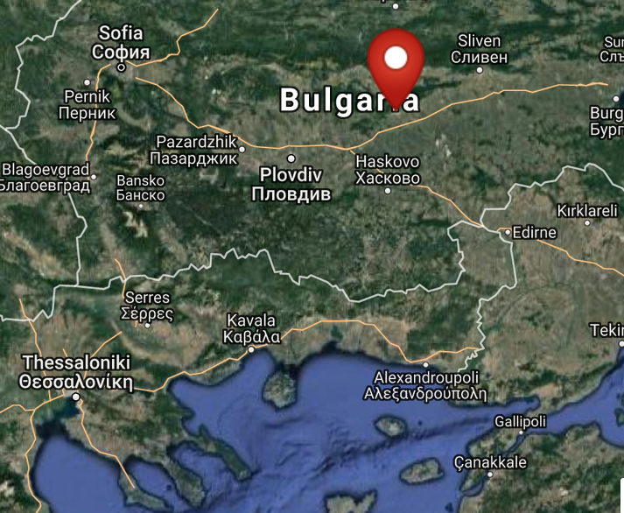

Fig. 2. Map of location of Stara Zagora, Bulgaria. From http://latitude.to/lat/42.42604/lng/25.63356

GPS coordinates: 42º25'33.74" N 25º38'0.81" E

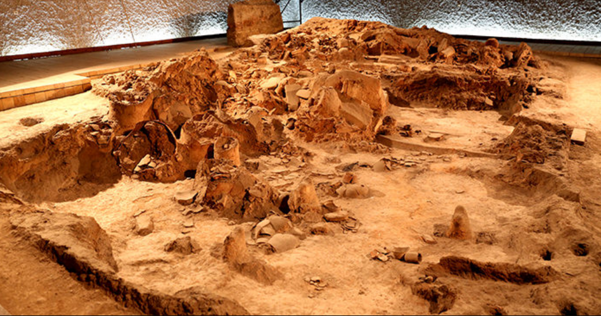

Fig. 3. Neolithic House, Stara Zagora regional Historical Museum, Bulgaria. http://www.getmetravelled.com/wp-content/uploads/2015/08/Neolithic-Dwellings-Museum_Stara_Zagora_Bulgaria.jpg

**Cultural Affiliation:** Neolithic.

**Medium:** Original, ceramic; replica is made of a ceramic material and painted with special varnish and paint.

**Dimensions: H** 51 mm; W 44 mm. **Weight: 14 gm**

**Provenance:** This is a restored reproduction. The original is in the Stara Zagora regional Historical Museum

**Condition:** Museum replica.

**Discussion:**

The original wasfound in the ruins of a Neolithic settlement in the region of Stara Zagora,.

**References:**

Gaul, James Harvey. [1948. *The neolithic period in Bulgaria : early food-producing cultures of Eastern Europe*](http://www.worldcat.org/title/neolithic-period-in-bulgaria-early-food-producing-cultures-of-eastern-europe/oclc/1001170812&referer=brief_results)*.*  Cambridge (Mass.): Peabody Museum.

[Krauß](http://www.worldcat.org/search?q=au%3AKrau%C3%9F%2C+Raiko.&qt=hot_author), Raiko; [Nedko Elenski](http://www.worldcat.org/search?q=au%3AElenski%2C+Nedko.&qt=hot_author" \o "Search for more by this author); [Bernhard Weninger](http://www.worldcat.org/search?q=au%3AWeninger%2C+Bernhard.&qt=hot_author); [Lee Clare](http://www.worldcat.org/search?q=au%3AClare%2C+Lee.&qt=hot_author); [Canan Çakirlar](http://www.worldcat.org/search?q=au%3AC%CC%A7akirlar%2C+Canan.&qt=hot_author" \o "Search for more by this author); [Petǎr Zidarov](http://www.worldcat.org/search?q=au%3AZidarov%2C+Peta%CC%8Cr.&qt=hot_author" \o "Search for more by this author). 2014. “Beginnings of the Neolithic in Southeast Europe: the early Neolithic sequence and absolute dates from Džuljunica-Smǎrdeš (Bulgaria),” *Documenta Praehistorica. Poročilo o raziskovanju paleolitika, neolitika in eneolitika v Sloveniji. Neolitske študije = Neolithic studies*, 41:51-77.

Todorova, Khenrieta. 1978. *The eneolithic period in Bulgaria in the fifth millennium B.C*. Oxford: British Archaeological Reports.